LAB 7: Zener Diodes and LEDs

**Date: Reg.#**

## OBJECTIVES:

## To study the behavior of zener diodes in reverse bias mode.

## To study the forward characteristics of LEDs.

## SUGGESTED READING:

* [Chapter 2: “p-n diodes”, *introductory Electronic Devices and Circuits by Paynter.*](http://arduino.cc/en/Guide/HomePage)
* Datasheet: Light Emitting Diode
* Datasheet: Zener Diode

## EQUIPMENT AND COMPONENTS:

* Basic Circuits Training Board
* Zener Diode
* Light Emitting Diode
* Jumper Wires
* Palm Scope / DMM

---------------------------------------------------------------------------------------------------------------------

## Zener Diode:

A special kind of diode that allows current in forwarding bias state, just like a regular diode, but also conducts in the reverse bias state above a certain threshold voltage known as ‘breakdown voltage’ or ‘Zener voltage’. Zener diodes are designed to have low breakdown voltages by creating a larger p-type material which is also heavily doped, and a much smaller n-type material. This causes the electrons to ‘tunnel’ through in reverse bias mode at low voltages.

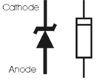

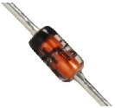

*Fig 2.1: Zener diode*

When the applied voltage in reverse bias increases from the ‘Zener voltage’, junction breakdown occurs and the zener diode starts to conduct in reverse bias.

**Forward Bias State:**

The Zener diode conducts just like a rectifier diode in the forward bias mode. It’s the reverse bias characteristics that we are interested in. This allows for their use as voltage regulators. A voltage regulator is a device that gives a constant voltage output, irrespective of the input voltage.

## Zener Diode Voltage Regulation:

A Zener diode is used in reverse bias to regulate the voltage across a load (Fig 2.2).

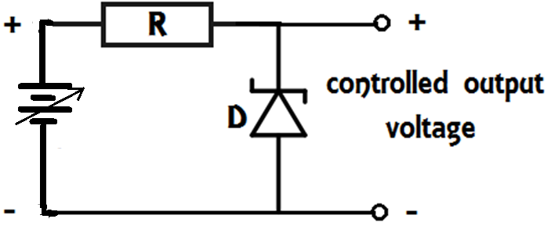

*Fig 2.2: Zener Diode Voltage Regulator*

## Procedure:

* Connect the Zener diode to the variable power supply of the basic circuit trainer board in the following configuration:

Don’t Forget to connect a current Limiting Resistance in the path of the Zener diode, so when you increase the voltage, the current does not exceed the limit.

* Increase the voltage from the variable voltage supply by a small step and measure the voltage at the output using the scope’s DMM function.
* Find the values of **current** flowing through the Zener diode and the load resistance.
* Repeat the process and record the values of input voltage, output voltage, the current through the diode, and current through the load.
* Apply the reverse bias voltage up to 15 volts and record the response of the diode.
* Display the readings in the form of a **table** below:

|  |  |  |  |
| --- | --- | --- | --- |
| **Input Voltage** | **Output Voltage** | **Current through diode** | **Current through the load resistance** |
|  |  |  |  |
|  |  |  |  |
|  |  |  |  |
|  |  |  |  |
|  |  |  |  |

## Input and Output Graph:

When both input and output are plotted on the same graph for some other independent variable (i.e. time, no of readings, etc.), one can observe the change in the output at a point for input. Use Microsoft Excel to plot the **input voltage** and the **output voltage** together, but with separate colors.

**Light Emitting Diodes:**

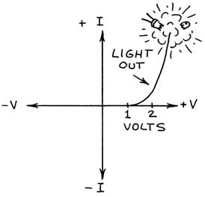The best known of all diodes is those that have the almost magical ability to emit light. Light-Emitting Diodes (LEDs) are available that emit all the colors of the visible spectrum from blue to red. White LEDs are blue LEDs with a special phosphor that glows white. LEDs have many uses as indicators and displays and in communications. Some emit invisible near-infrared. These LEDs are used in remote controls for TV sets and to link computers with other computers. The graph shows how a Light-Emitting Diode conducts much like a standard diode.

A Light Emitting Diode must never be connected directly across the voltage source. A current limiting resistor should be connected in series with the LED.

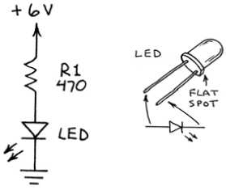

*Fig 2.3: Testing an LED*

## Procedure:

* Connect the LED with a switch on the trainer board. Connect a resistor in series with the LED for limiting the current flowing through the LED.
* Use the switch to turn the LED ON or OFF.
* Use the following formula to find the current when the current limiting resistor is connected to the circuit.



* Measure the current through the LED using the DMM.
* Attach the following circuit and analyze the circuit.

|  |  |  |  |
| --- | --- | --- | --- |
| **Input Voltage** | **Resistance** | **Voltage across LED** | **Current through LED** |
|  |  |  |  |
|  |  |  |  |
|  |  |  |  |
|  |  |  |  |
|  |  |  |  |

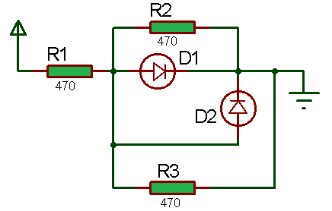

*Fig 2.4: LED test circuit*

# REVIEW QUESTIONS:

Q: From the circuit given in fig.2.4, which LED should turn ON? If both the LEDs don’t turn ON, what could be the reason?

Q: What was the forward voltage drop of the LEDs used in the last experiment?

Q: How does the brightness of the LED vary with the current flowing through the LED?

Q: Zener diodes are designed to operate between what two states?

Q: What happens when a Zener diode is used in forwarding bias mode?

Q: Write any three applications of a Zener diode.

**Question**: Do you think that Zener diode voltage regulators are efficient? Why?

**Question**: How can you use two different color LEDs in parallel?